Structured query language
This was originally named SEQUEL (Structured English QUEry Language)
- Designed and implemented by IBM Research as an interface of experimental relational database SYSTEM R
  - High-level “non-navigational” language, ad-hoc queries
  - Support rapidly changing database environment
- Used for data definition as well as queries and updates (both DDL and DML)
- SQL can also specify authorization and security, define integrity constraints, define views, specify transaction controls.
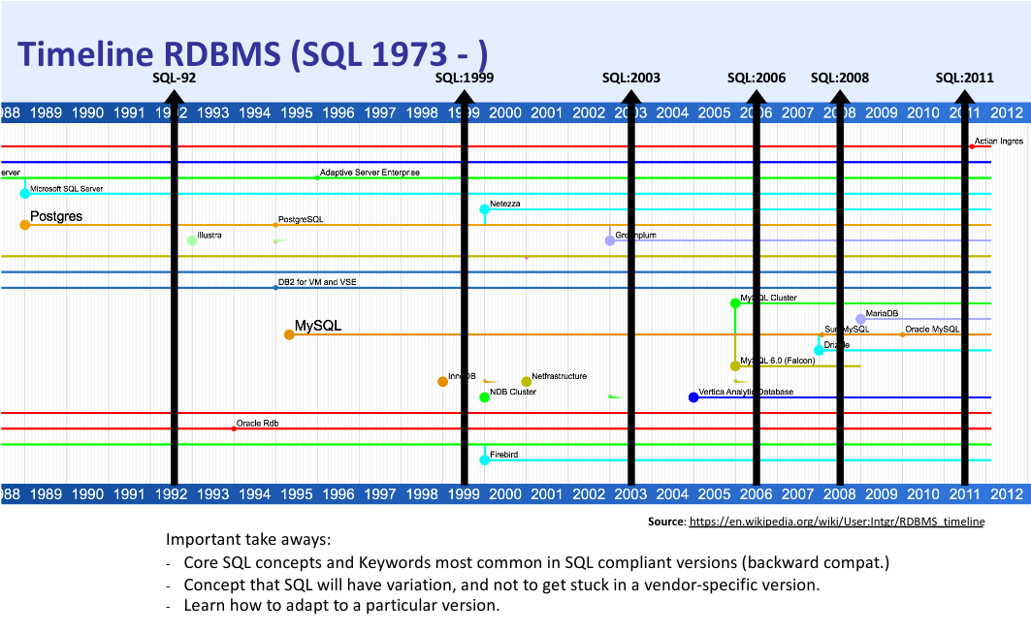

Relational model terms and sql terms
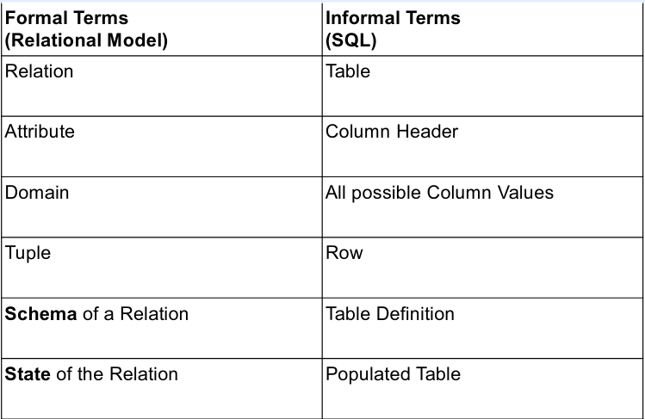

Data definition, Constraints and schema changes
Data Definition Language (DDL) Commands:
- CREATE – Create a description of the relations
- DROP – Delete the descriptions
- ALTER – Update the descriptions

Create schema
- Specifies a new database schema by giving it a name.
CREATE SCHEMA COMPANY AUTHORIZATION JSMITH;

- Selects a schema to be defined:
USE COMPANY;

- Multiple schemas exist within a database, although some RDBMSs have schema and a database as a synchronous concept.
- Comments:
--line comments are two dashes

So to create the table DEPARTMENT:
CREATE TABLE DEPARTMENT (
DNAME VARCHAR(10) NOT NULL,
DNUMBER INTEGER NOT NULL,
MGRSSN CHAR(9),
MGRSTARTDATE DATE
);

- Specifies a new base relation by giving it a name, and specifying each of its attributes.
- In SQL, attributes are ordered based on the order they are specified.
- Attributes can have initial constraints defined, as in NOT NULL

Attribute names and table names reserved words in sql
- Vendor specific… and can be a long list…
- How to deal with reserved words? Use back-ticks if you really want to use reserved words.
`GROUP` INTEGER NOT NULL
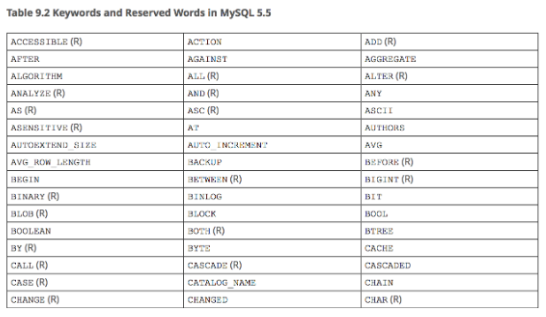

Attribute data types

Integer
- INT or INTEGER are signed implicitly
- UNSIGNED INTEGER are unsigned
- INT(n) denotes the number of digits (i.e. INT(2) 0-99)
- Size depends on implementation
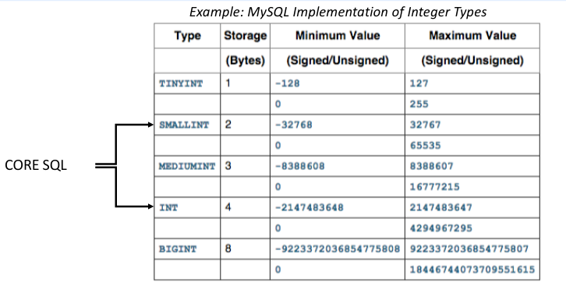

Real numbers
Approximate Value:
- FLOAT, REAL, DOUBLE
- Can specify digit precision (DB does rounding)
- FLOAT(n)
  - n – precision, as in number of bits used to store the mantissa of the float number in scientific notation
- Example: FLOAT(24) holds a single precision floating point number
Exact Value (Fixed-Point Type):
- DECIMAL(i, j) for exact formatted numbers
  - i – precision, total number of digits to store number
  - j – scale, after decimal
- Example: DECMIAL(7, 4) will look like -999.9999 when displayed

String
- CHAR(n), CHARACTER(n) – Fixed length, right padded with spaces
- VARCHAR(n), CHAR VARYING(n), CHARACTER VARYING(n) – Varying length
- CLOB / TEXT – Character Large Object
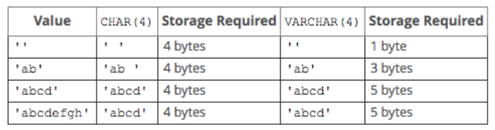

Binary Data
- BIT(n) – Fixed length
- BIT VARYING(n) – Varying length
- BLOB – Binary Large. Megabyte, Gigabyte.
Typically, people do not store files (images etc.) or documents in a RDBS. They are stored on a File System with reference.
PRO TIP: Do hash your binary data and store that in the DB with the metadata (Use “md5 hash” of your binary data).

Boolean
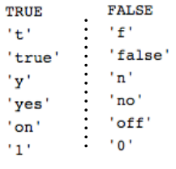
- BOOLEAN – TRUE or FALSE
- Can implement with BIT(1) – 1 bit
- Implementations vary, examples:
  - MySQL uses a BIT(1), so 0 or 1 as False/True
  - PostgreSQL stores these as any of these literals →
Any data type can also be NULL…

Null
- Attributes in SQL can have the value of NULL (unless of course they are specified with NOT NULL constraints)
- NULL means Unknown data, and does not mean False.
- With Boolean values and Conditionals, there is a Three Value Logic System in SQL
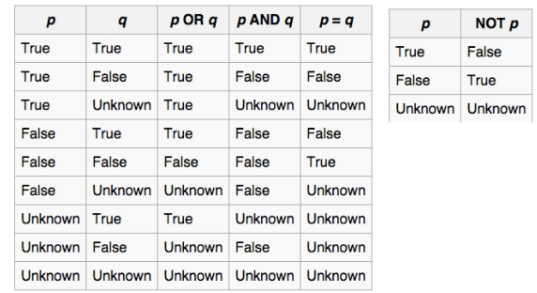

Date and time
- DATE – Made up of year-month-day (“yyyy-mm-dd”)
- TIME – Made up of hour:minute:second (“hh:mm:ss”)
- TIME(i) – TIME plus I addition digits for fractions of second
  - TIME(3) → precision for milliseconds
- DATETIME/TIMESTAMP – both DATE and TIME components

Interval
INTERVAL – relative time value as opposed to absolute
- Can be DAY/TIME intervals of YEAR/MONTH intervals
- Can be positive or negative when added to or subtracted from an absolute value, the result is an absolute value
Examples of Interval Values that can be stored: INTERVAL 1 DAY, INTERVAL 3 MONTH, INTERVAL 2 HOUR

Complex types
- Special types:
  - CURRENCY, MONEY
- Spatial Types (GIS)
  - GEOMETRY type can store gemoetries
    - POINT(0 0)
    - LINESTRING(0 0, 1 1, 1 2)
    - POLYGON((0 0, 4 0, 4 4, 0 4, 0 0), (1 1, 2 1, 2 2, 1 2, 1 1))
- Enumerated Types: ENUM(“One”, “Two”, “Three”)
- Collection Types: SET, VALUE_MAP

Creating domains
- CREATE DOMAIN – Allows you to specify your own data type to use in schema
CREATE DOMAIN SSN AS CHAR(9);

- Need to CREATE DOMAIN before utilizing in CREATE TABLE

Specifying integrity constraints
- NOT NULL – for enforcing that attributes cannot take NULL values
DNUMBER INTEGER NOT NULL;
- DEFAULT <value>
MGRSSN CHAR(9) DEFAULT ‘123456789’;
- AUTO_INCREMENT – For INTEGER types, helpful with IDs (usually starts with 1, but check implementation…)
DNUMBER INTEGER NOT NULL AUTO_INCREMENT

Check
- CHECK clause – requires a valid conditional expression
DNUMBER INT CHECK (DNUMBER > 0 AND DNUMBER < 21);
- Use with CREATE DOMAIN (note the use of VALUE to reference the attribute name):
CREATE DOMAIN D_NUM AS INTEGER CHECK (VALUE > 0 AND VALUE < 21);

- Check is unable to compare against other attributes/relations – need to use an ASSERTION

Key and referential integrity constraints
- PRIMARY KEY clause
DNUMBER INT PRIMARY KEY;

- UNIQUE clause – for secondary/alternate keys
DNAME CHAR(9) UNIQUE;

- FOREIGN KEY clause – for referential integrity
FOREIGN KEY (MGRSSN) REFERENCES EMPLOYEE(SSN);

Integrity constraints
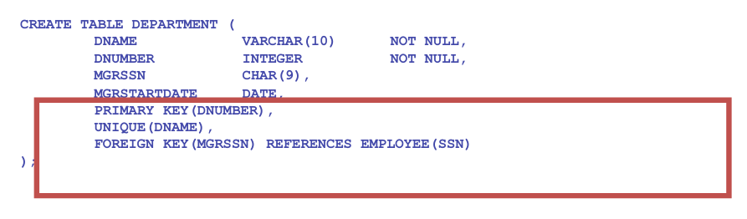

- CREATE TABLE can specify primary key attributes, secondary keys, and referential integrity constraints (foreign keys) after the attributes.
- Key attributes specified via PRIMARY KEY and UNIQUE

Composite primary and foreign keys
Composite PRIMARY or FOREIGN KEYS are specified after the attributes
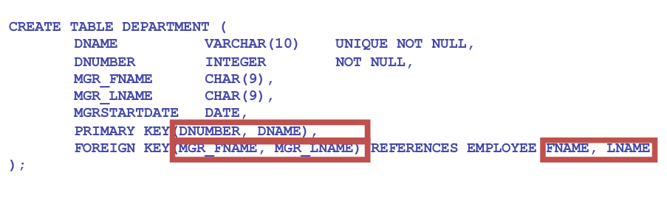

Referential integrity OPTIONS
- A referential integrity constraint may be violated when tuples in the referenced tuple are updated/deleted.
- Default: reject the operation that violates constraint
- Or: Specify a referential triggered action, options:
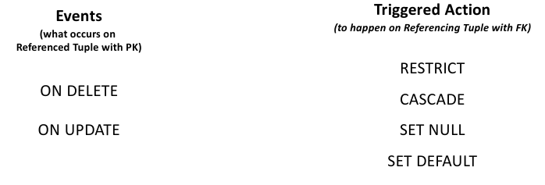
Example:
ON DELETE SET NULL
ON UPDATE CASCADE

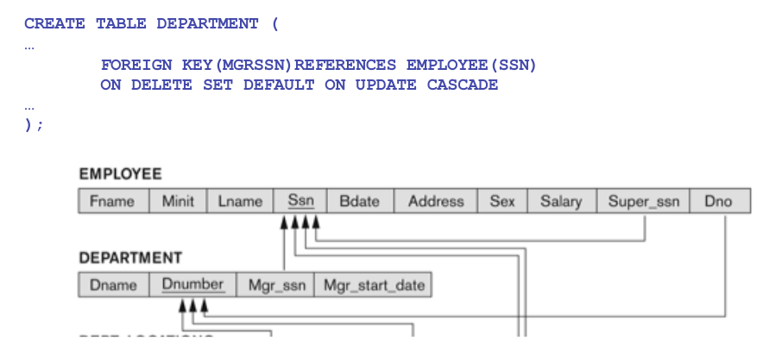
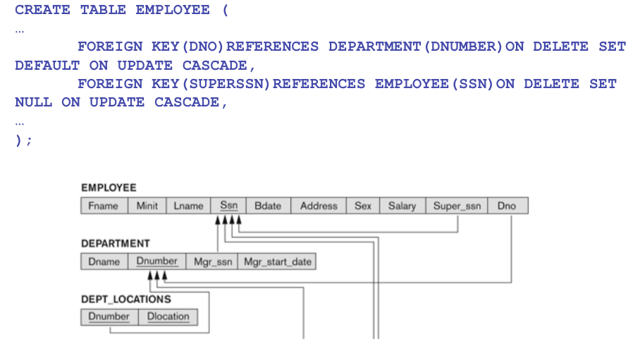

Base relations vs. Virtual relations
- Base tables (or base relations): Relations and tuples store as a file by DBMS
  - Created through the CREATE TABLE statement
- Base tables are distinguished from virtual relations which may not correspond to an actual physical file
  - Created through the CREATE VIEW statement
- Remember: while attributes in CREATE TABLE are ordered, tuples (rows) are not considered ordered.


Drop table
- Used to remove a relation (base table) and its definition
- Relation is unable to be used in queries, updates, or any commands since its description no longer exists
- Example
DROP TABLE DEPENDENT;

- Table dropped if not referenced in any constraints
DROP TABLE DEPENDENT RESTRICT;

- All constraints that reference table are dropped along with table.
DROP TABLE DEPENDENT CASCADE;

Drop schema
- Used to remove the entire schema
- Similar distinction with RESTRICT vs. CASCADE as with DROP TABLE
- Dropped only if no elements in schema
DROP SCHEMA COMPANY RESTRICT;

- ALL tables, views, and constraints dropped (!!!)
DROP SCHEMA DEPENDENT CASCADE;

Alter table

Add
Used to add an attribute to one of the base relations
- New attribute will have NULLS in all existing tuples of relation
ALTER TABLE EMPLOYEE ADD JOB VARCHAR(12);

- Database users will need to UPDATE a value for the new JOB attribute for the existing Employees.
- Utilize a DEFAULT value
ALTER TABLE EMPLOYEE ADD JOB VARCHAR(12) DEFAULT ‘President’;

- Specifying NOT NULL will require a DEFAULT value.

Add constraints
Depending on which order tables are created, circular Referential Integrity Constraints may need to be added later.
- Example, DEPARTMENT and EMPLOYEE reference each other:
ALTER TABLE EMPLOYEE ADD FOREIGN KEY (DNO) REFERENCES DEPARTMENT (Dnumber);

ALTER TABLE DEPARTMENT ADD FOREIGN KEY (MGRSSN) REFERENCES EMPLOYEE (Ssn);

DROP
- Can remove attributes (which removes data), although some RDBS do not allow removing columns
ALTER TABLE EMPLOYEE DROP JOB;

- Need to specify the FOREIGN KEY to DROP a constraint.
ALTER TABLE DEPARTMENT DROP FOREIGN KEY (MGRSSN);

Data manipulation Language

Retrieval queries in sql

Bags vs. sets
- A bag or multi-set is like a set, but an element may appear more than once.
{A, B, C, A} is a a bag.
{A, B, C} is also a bag that is also a set
- Bags also resemble lists, but order is irrelevant in a bag.
{A, B, A} = {B, A, A} as bags
However, [A, B, A] =/= [B, A, A] as lists
- SQL can enforce sets with Key Constraints and DISTINCT
- Ordered relations (lists) with ORDER BY

SELECT FROM WHERE
- Basic form of the SQL SELECT statement is called a mapping, or a SELECT-FROM-WHERE block
SELECT <attribute list>
FROM <table list>
WHERE <condition>

- <attribute list> is a list of attribute names whose values are to be retrieved by the query
- <table list> is a list of the relation names required to process the query
- <condition> is a conditional (boolean) expression that identifies the tuples to be retrieved by the query

Where conditions
Basic Logical Operators in the <condition> : =, <, <=, >, >=, <>, !=, AND, OR, NOT, IS NULL, IS NOT NULL
WHERE DNO = 5
WHERE (DNO = 5) AND (PNUMBER > 1)

Simple sql queries and relational algebra
- Basic SQL queries correspond to using the following operations of the relational algebra
  - SELECT operator
  - PROJECT operator
  - JOIN

Simple query on one relation
- Retrieve the birthdate and address of the employee whose name is ‘John B. Smith’.
SELECT BDATE, ADDRESS
FROM EMPLOYEE
WHERE FNAME=”John” AND MINIT=”B” AND LNAME=”Smith”

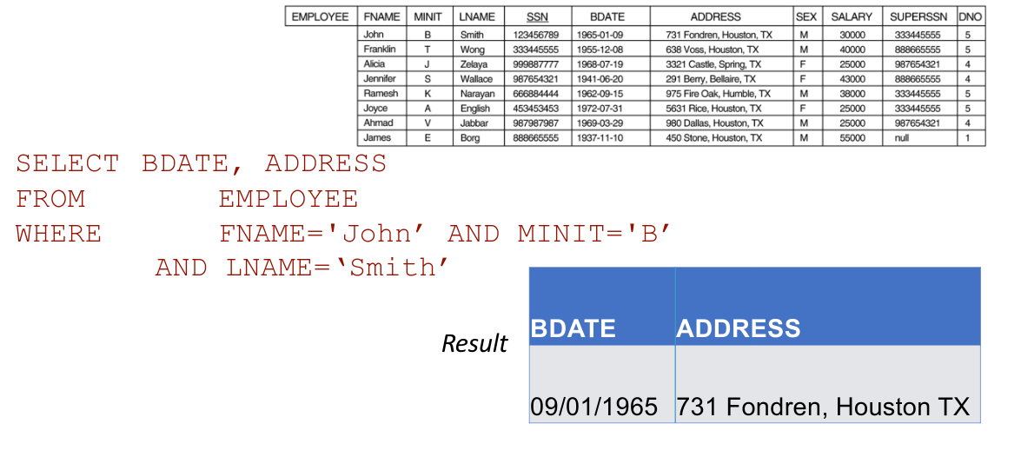

simple query with more than one relation
- Retrieve the name and address of all employees who work for the ‘Research’ department.
SELECT FNAME, LNAME, ADDRESS
FROM EMPLOYEE, DEPARTMENT
WHERE DNAME = ‘RESEARCH’ AND DNUMBER = DNO
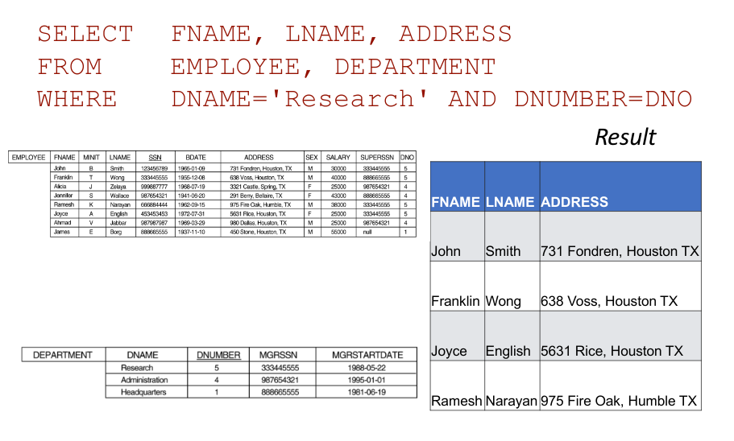

The join condition
What happens if the condition DNUMBER = DNO is omitted?
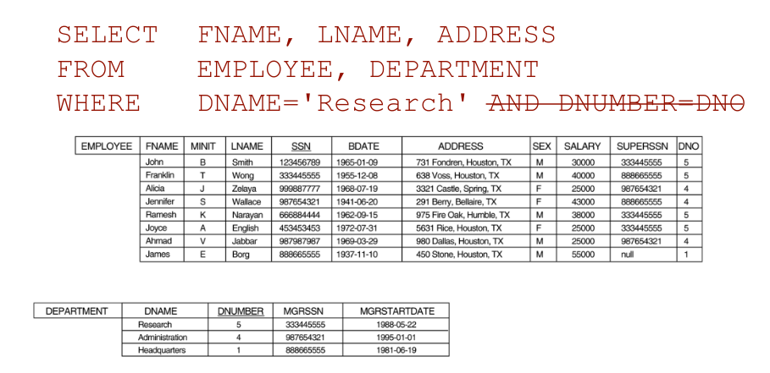

All rows are selected
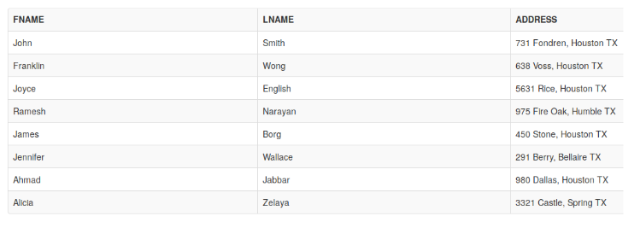

select from more relations
- For every project located in ‘Stafford’, list the project number, the controlling department number, and the department manager’s last name, address, and birthdate
SELECT PNUMBER, DNUM, LNAME, ADDRESS, BDATE
FROM PROJECT, DEPARTMENT, EMPLOYEE
WHERE DNUM=DNUMBER AND MGRSSN=SSN AND PLOCATION=’STAFFORD’

Two Join conditions:
- The join condition DNUM=DNUMBER relates to a project to its controlling department.
- The join condition MGRSSN=SSN relates the controlling department to the employee who manages that department.
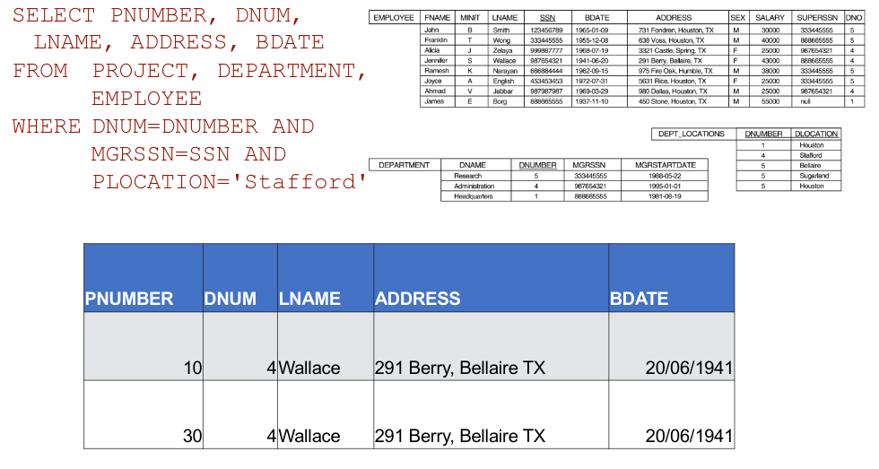

Qualification of relation names
- In SQL, we can use the same name for multiple attributes as long as the attributes are in different relations
- If two or more attributes in different relations have the same name, we need to specify them by the relation name.
- We can qualify the attribute name with the relation name by prefixing the relation name to the attribute name.
E.g. Unique attribute names
SELECT EMPLOYEE.FNAME, EMPLOYEE.LNAME, EMPLOYEE.ADDRESS
FROM EMPLOYEE, DEPARTMENT
WHERE DEPARTMENT.DNAME='Research' AND DEPARTMENT.DNUMBER=EMPLOYEE.DNO

Aliases
- Some queries need to refer to the same relation twice
- Aliases can be given to the relation names
For each employee, retrieve the employee’s name, and the name of his or her immediate supervisor.
SELECT E.FNAME, E.LNAME, S.FNAME, S.LNAME
FROM EMPLOYEE E, EMPLOYEE S
WHERE E.SUPERSSN=S.SSN

- Alternate relation names E and S are called aliases or tuple variables for the EMPLOYEE relation
- Think of E and S as two different copies of EMPLOYEE; E represents employees in role of supervisees and S represents employees in role of supervisors
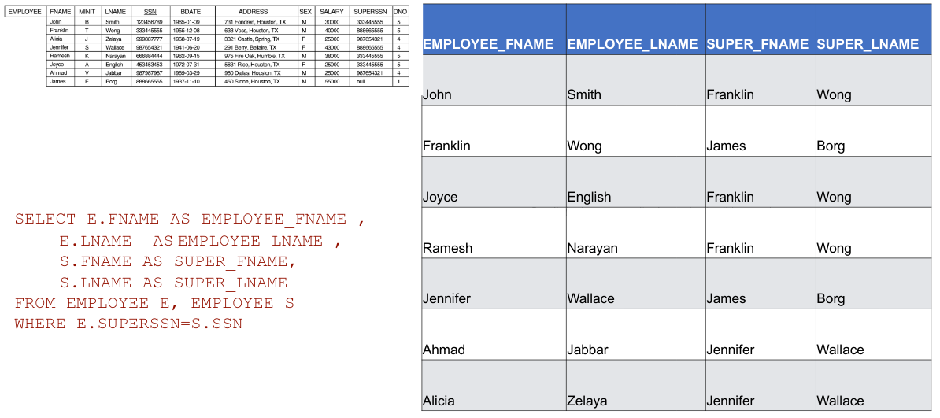

UNSPECIFIED WHERE CLAUSE
- A missing WHERE-clause indicates no condition – all tuples of the relations in the FROM-clause are selected.

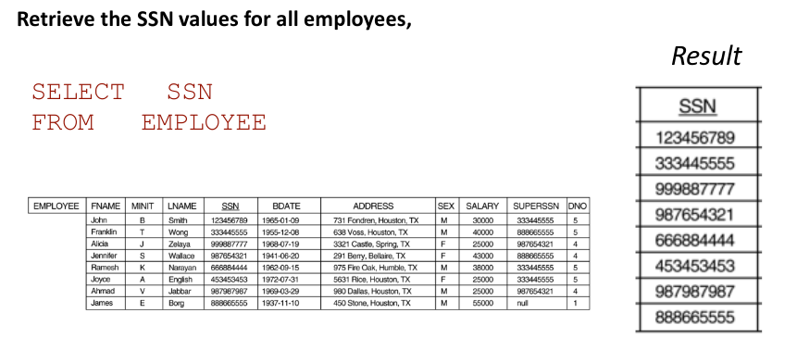
Cartesian product
- If more than one relation is specified in the FROM-clause and there is no join condition, then the CARTESIAN PRODUCT of tuples is selected.
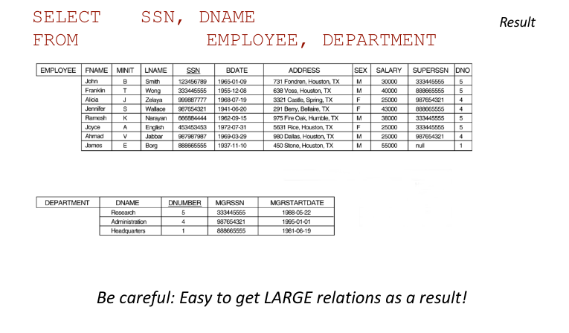
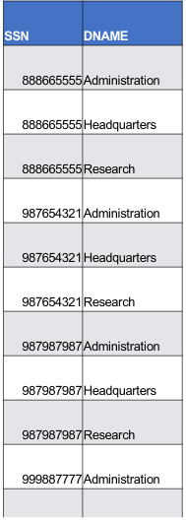

Use of *
To retrieve all values in tuples, a * is used.
SELECT *
FROM EMPLOYEE
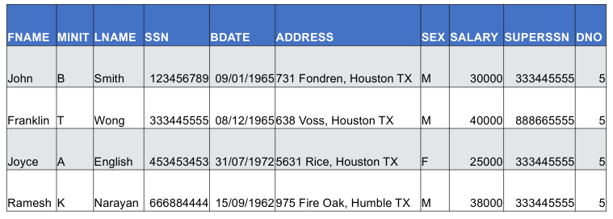
WHERE DNO=5

use of distinct
- SQL does not treat a relation as a set; duplicate values can appear
- To eliminate duplicate tuples in a query result, the keyword DISTINCT is used
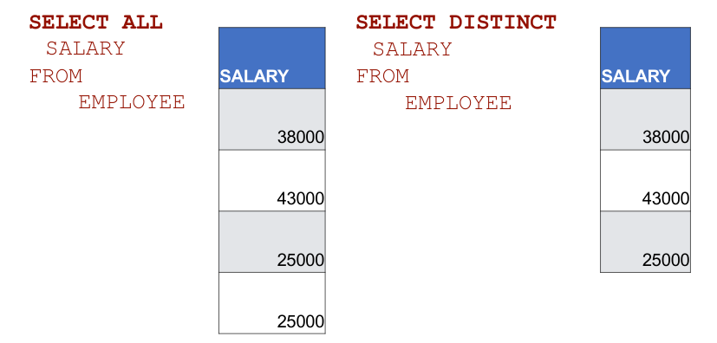

- Using DISTINCT with more than one attribute, creates a SET of the resulting tuples.
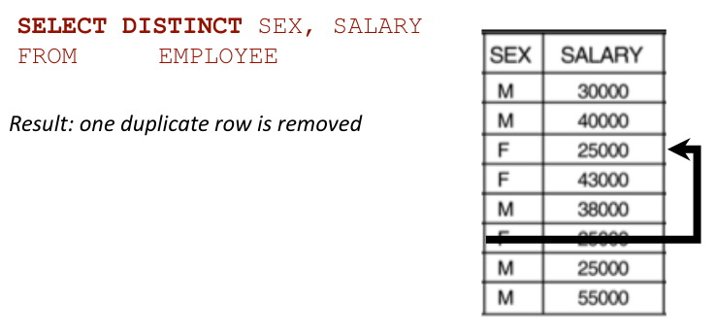

Set Operations
SQL has directly incorporated some set operations
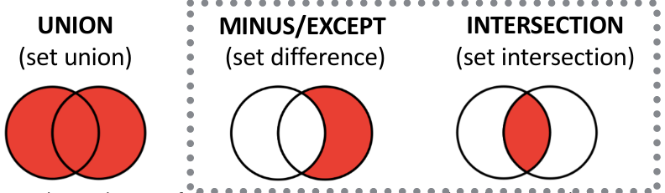
- Resulting relations of these set operations are sets of tuples – duplicate tuples are eliminated from the result
- Set operations apply only to union compatible relations:
  - Two relations must have the same number of attributes
  - Each corresponding pair of attributes has the same domain

UNION
- Make a list of all project numbers for projects that involve an employee whose last name is ‘Smith’ as a worker or as a manager of the department that controls the project.
(SELECT PNUMBER
FROM PROJECT, DEPARTMENT, EMPLOYEE
WHERE DNUM = DNUMBER AND MGRSSN=SSN AND LNAME = ‘SMITH’)
UNION
(SELECT PNUMBER
FROM PROJECT, WORKS_ON, EMPLOYEE
WHERE PNUMBER = PNO AND ESSN = SSN AND LNAME = ‘SMITH’)

Substring comparison/pattern matching
- The LIKE comparison operator is used to compare partial strings
- Two reserved characters are used:
  - ‘%’ (or ‘*’ in some implementations) replaces an arbitrary number of characters
  - ‘_’ replaces a single arbitrary character
- Usually use an escape-character ‘\’ to specify these reserve characters in your search string
  - LIKE ‘%15\%%’
Retrieve all employees whose address is in Houston, Texas. Here, the value of the ADDRESS attribute must contain the substring ‘Houston, TX’ in it.
SELECT FNAME, LNAME
FROM EMPLOYEE
WHERE ADDRESS LIKE ‘%Houston, TX%’
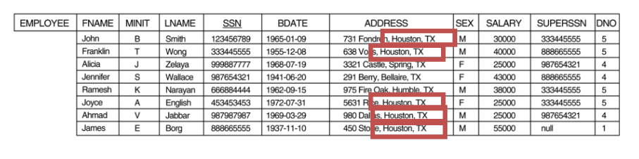

Retrieve all employees who were born during the 1950s
SELECT FNAME, LNAME
FROM EMPLOYEE
WHERE BDATE LIKE ‘_ _ 5 _ _ _ _ _ _’

- LIKE operator different from the formal relational model which considers each attribute value as atomic and indivisible.
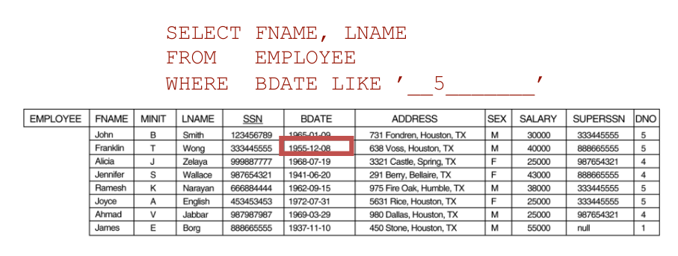

ARITHMETIC OPERATIONS
- The standard arithmetic operators +, -, *, and / can be applied to numeric values in an SQL query result
- Show the effect of giving all employees who work on the ‘ProductX’ project a 10% raise.
SELECT FNAME, LNAME, 1.1*SALARY
FROM EMPLOYEE, WORKS_ON, PROJECT
WHERE SSN=ESSN AND PNO=PNUMBER AND PNAME=’ProductX’

ORDER BY
The ORDER BY clause is used to sort the tuples in a query result based on the values of some attribute(s)
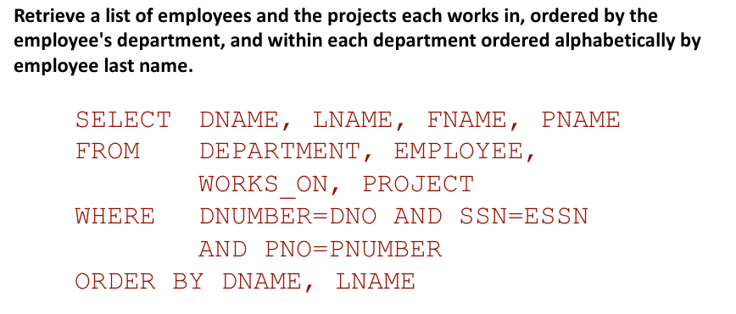

- The default order is in ascending order of values.
- We can specify the keyword DESC if we want a descending order; the keyword ASC can be used to explicitly specify ascending order, even though it is the default
